**Hardware Information**

This document lists the hardware devices used in the “BionicKitchen” project, as well as their description, function and specifications of each device.

**Hardware Devices:**

[Image 1 – Hardware Diagram](file:///C:\SVN\BionicKitchen\Documentation\Hardware information.docx" \l "_Toc500773674) 3

[I. Raspberry Pi 3 Model B 3](#_Toc500773675)

[Image 2 - GPIO Header´s](file:///C:\SVN\BionicKitchen\Documentation\Hardware information.docx" \l "_Toc500773676) 4

[II. Monitor 4](#_Toc500773677)

[III. RFID Technology 5](#_Toc500773678)

[IV. Buttons 5](#_Toc500773679)

***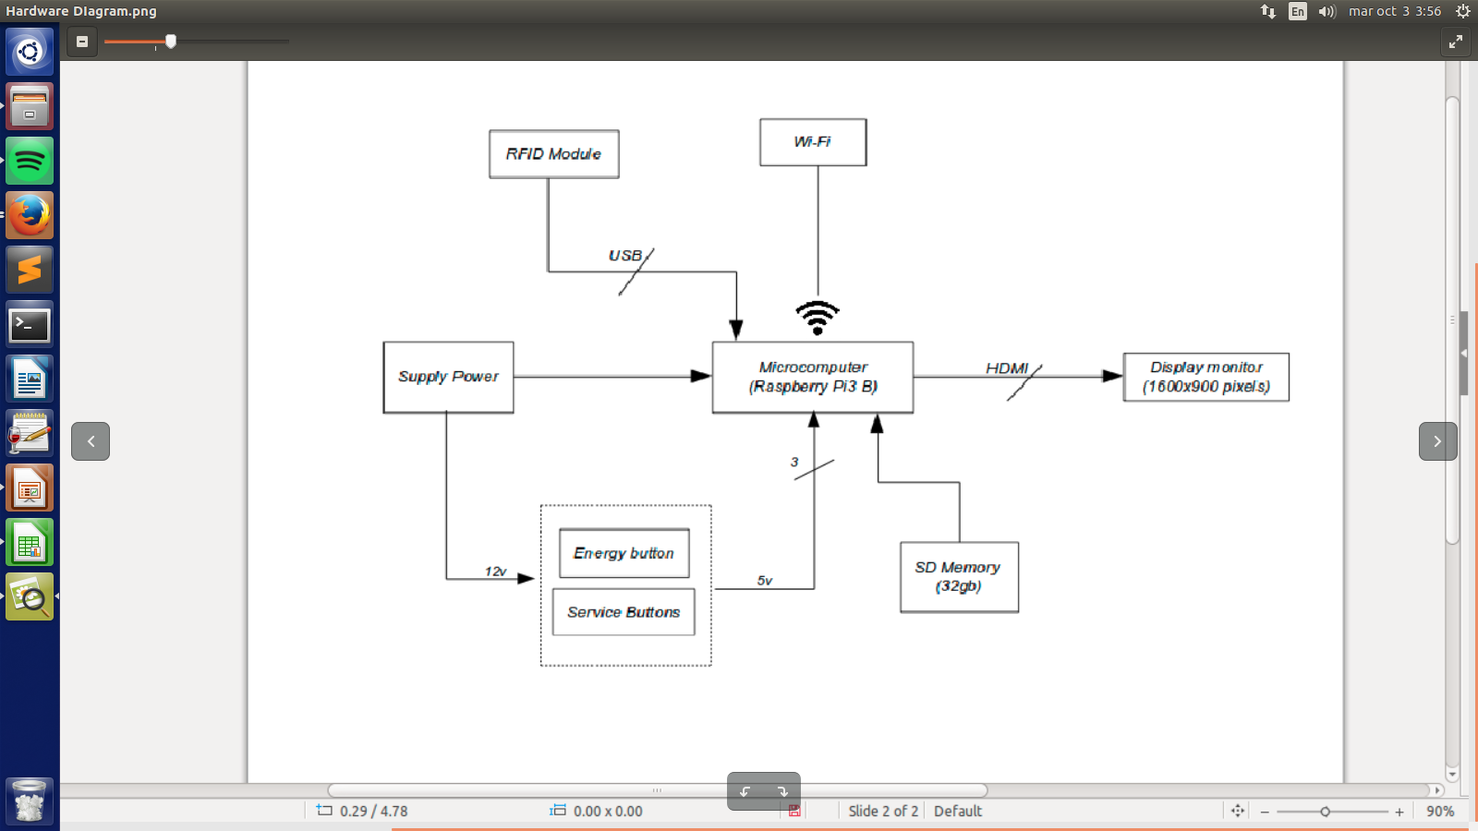***

# ***Image 1 – Hardware Diagram***

# **Raspberry Pi 3 Model B**

Microprocessor where all the software of the "Bionic Kitchen" project is stored, this will be in charge of execute the scripts and will fulfill the function of a server (save information).

**Specifications:**

|  |  |  |  |
| --- | --- | --- | --- |
| **Microprocessor (CPU)** | 1.2GHz 64-bit quad-core ARMv8 | **Network connectivity** | Ethernet (RJ-45) via hub USB,​ Wi-Fi 802.11n, Bluetooth 4.1 |
| **Memory (SDRAM)** | 1 GB | **Low-level peripherals** | 17 x GPIO and a bus HAT ID |
| **USB ports** | 4 | **Energy consumption** | 800mA, (4.0W) |
| **Video Outputs** | RCA connector (PAL and NTSC), *HDMI* (Rev1.3 and 1.4), 58 DSI interface for LCD panel | **Power supply** | 5V via Micro USB or GPIO header |
| **Sound Outputs** | 3.5 mm connector, HDMI (NORMAL) | **OS & Kernel** | Debian (Raspbian Jessie 4.9.51-v7+) |
| **Integrated storage** | Micro SD of 32 GB |  |  |

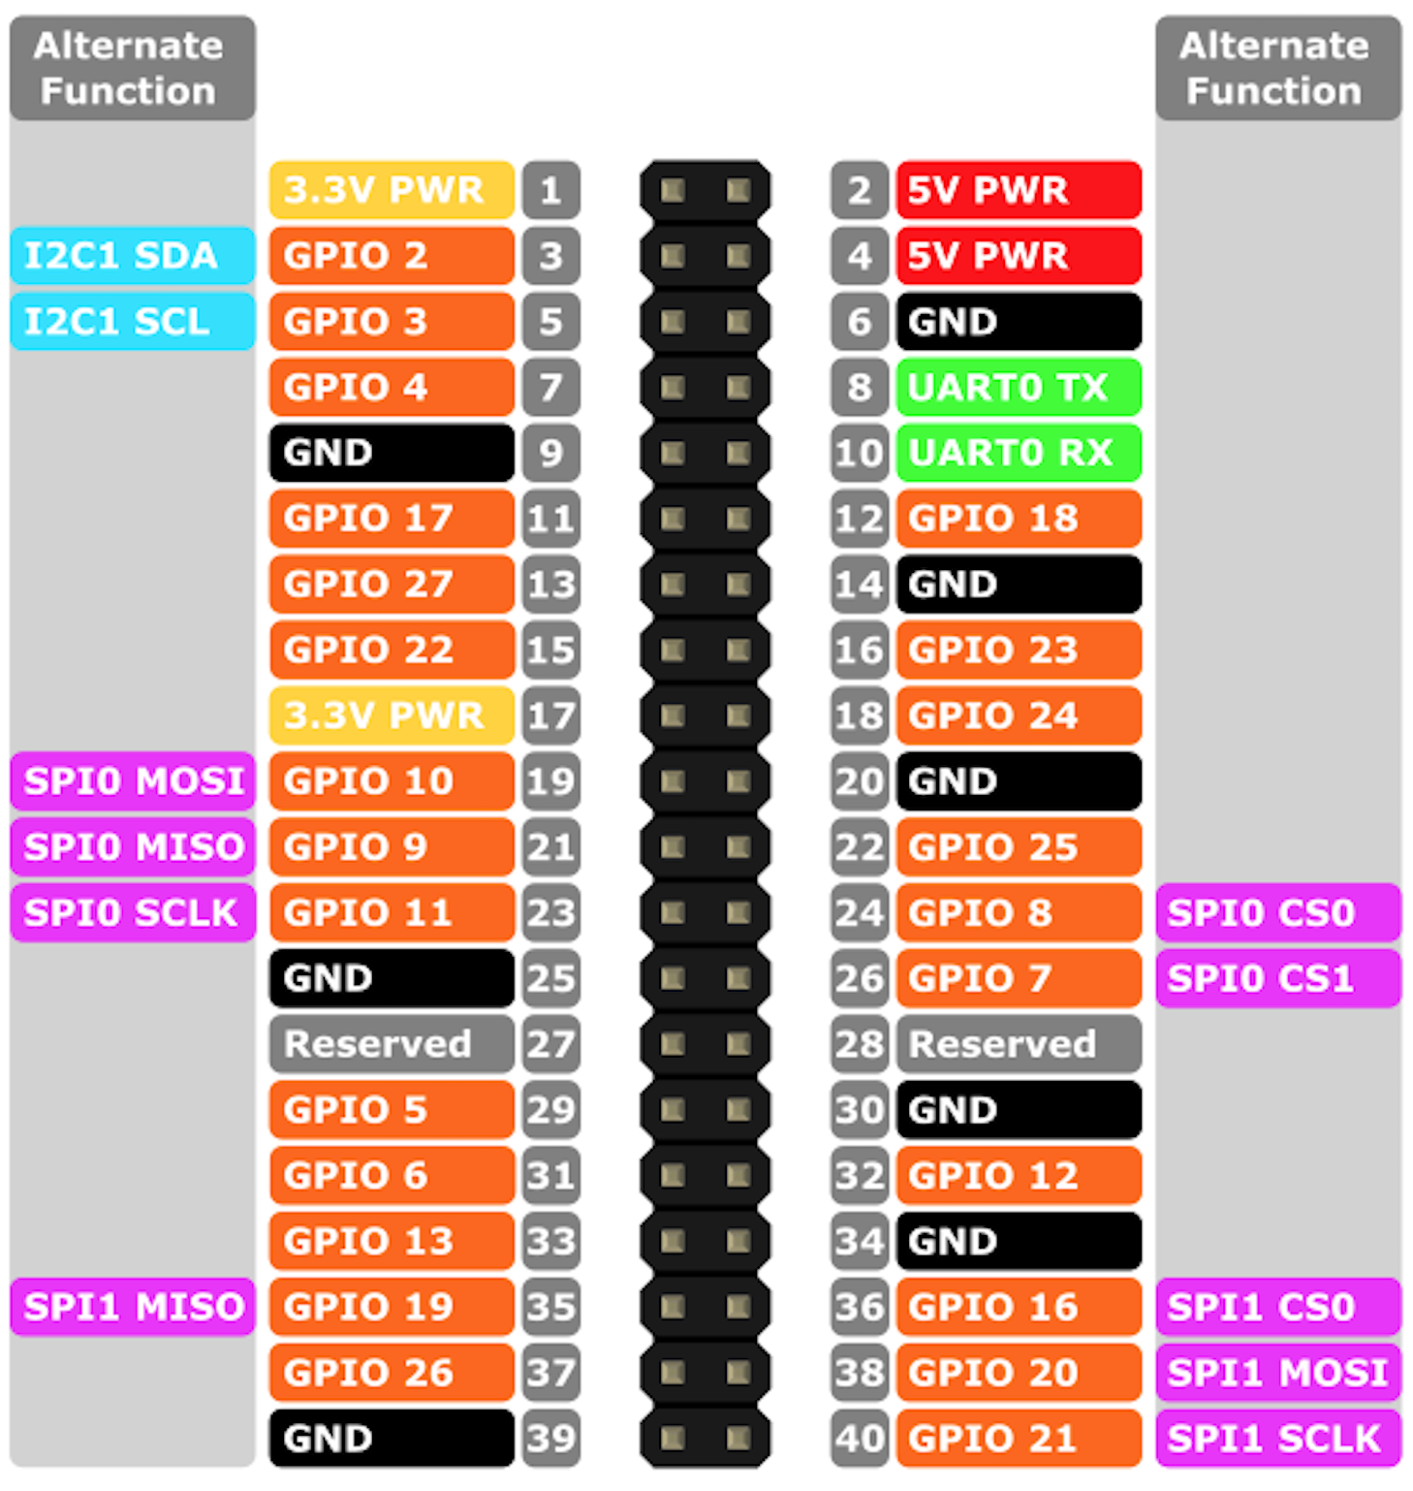

# ***Image 2 - GPIO Header´s***

**For the project:**

* The video output will be through HDMI. (Ref. [Monitor section](#_Monitor))
* The connection to the network will be through Wi-Fi.
* The power will be through 5V via Micro USB with a Raspberry Pi 3 Adapter.
* The GPIO's will be the inputs for the push buttons. (Ref. [Button section](#_Buttons))
* The RFID module will be connected through one of the USB ports. (Ref. [RFID Technology section](#_RFID_Technology))

# **Monitor**

The monitor is the video output, its main function will be to show the main program of the BionicKitchen project.

* Connexion via HDMI to Raspberry. (Ref. [Raspberry section](#_Raspberry_Pi_3))
* 1600x900 resolution (16:9).
* HD+ monitor.

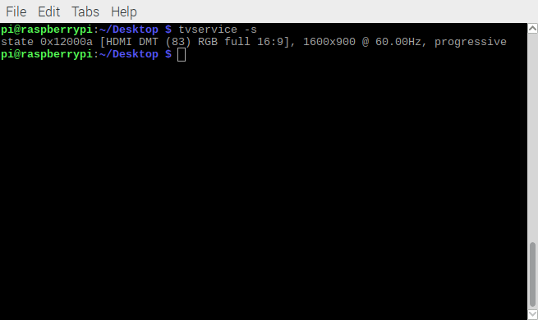

# **RFID Technology**

RFID (Radio Frequency Identification) is a wireless remote identification technology in which a reader device connected to computer equipment, communicates through an antenna with a tag (known as badge for BionicKitchen project) by radio waves.

The BionicKitchen project works with the Parallax RFID Card Reader, USB (# 28340).

**Specifications:**

* Direct USB Connexion to Raspberry (Ref. [Raspberry section](#_Raspberry_Pi_3)).
* Powered from the host Raspberry USB port and uses an industry-standard FTDI FT232R device to provide the USB connectivity.
* Reads passive RFID tag of 125 kHz only.
* Works exclusively with the EM Microelectronics EM4100-family of passive read-only tags. Each tag contains a unique, read-only identifier (one of 2 40, or 1,099,511,627,776 possible combinations).
* Bi-color LED for visual indication of status.

**\*NOTE:** For the more specifications, check the [PDF document](file:///D:\Documentation\RFID Reader Documentation.pdf) of the RFID Module in the folder documentation of the BionicKitchen project.

# **Buttons**

The BionicKitchen project uses four push buttons, three of them for the kitchen service, and one more for the power supply of the Raspberry.

**General specifications:**

* Type of connection: Pull Down.
* Resistor size: 220 Ohms 1% (for Buttons).

NOTE: In case of using led, the size of the resistance will vary (for led only).

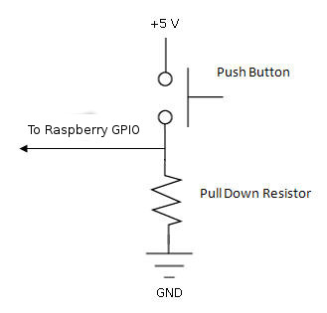

***Image 3 – Pull Down Button Circuit***

**Service buttons specifications:**

* 100 mm in diameter.
* Work with 5V (powered by Raspberry).
* Led of button work with 12V, power externally, because Raspberry provides 5V maximum.
* Served button: This buttons indicate that the employee was served, and the RFID Module can read another badge.
* Color green.
* Connected to GPIO 17. (Ref. [Image 2 – GPIO Header´s](#_Image_2_-))
* Canceled button: This buttons indicate that the employee wasn’t served, and the RFID Module can read another badge.
* Color yellow.
* Connected to GPIO 27. (Ref. [Image 2 – GPIO Header´s](#_Image_2_-))
* Close program button:
* Color red.
* Close the main program (GUI), and saved information.
* Connected to GPIO 22. (Ref. [Image 2 – GPIO Header´s](#_Image_2_-))

**Energy button specifications:**

* Size: 12x12x7.3 mm.
* Work with 5V (powered by Raspberry).
* Connected to GPIO 3. (Ref. [Image 2 – GPIO Header´s](#_Image_2_-))
* Color white (TBD).
* Turn on and turn off Raspberry.
* When turn on Raspberry, automatically runs main program of the BionicKitchen project.
* When turn off Raspberry, close all the programs before to avoid damages.